Adaptive Multi-Site Stimulation Control Using Reinforcement Learning in an MDP
Learning Sequential Stimulation Policies Under State-dependent EEG Response Dynamics
Fatih Karatay, Cody Moxam
EN.705.741.8VL.SP26
April 12, 2026
Abstract

Adaptive neurostimulation is not always a static target-selection problem because stimulation history may alter later responsiveness and reward quality. We model adaptive multi-site stimulation as a finite-horizon Markov decision process in which an agent selects among four stimulation sites while patient-response state evolves among baseline, receptive, and non-receptive modes. Four model-free reinforcement-learning methods—Monte Carlo Control, Q-Learning, Expected SARSA, and Double Q-Learning—were compared with a Value Iteration benchmark across response-separation levels, episode horizons, and switching costs (90 configurations; 10 seeds each). Temporal-difference methods consistently outperformed Monte Carlo Control, while no statistically significant differences were detected among Q-Learning, Expected SARSA, and Double Q-Learning. Value Iteration achieved higher return in the high- and moderate-separation settings. Increasing switching cost reduced switching frequency but increased non-receptive state occupancy, revealing a control tradeoff. These results support framing state-dependent adaptive stimulation as a sequential control problem rather than static arm selection.

Introduction
Brain stimulation site selection is often framed as choosing the single best target. In a static formulation, the problem resembles a multi-armed bandit: reward is sampled from fixed action distributions and the optimal strategy is to identify the highest-value arm. Clinical neurostimulation, however, is often history-dependent rather than static. Repeated stimulation can alter subsequent tissue responsiveness, so current actions may influence future reward quality and future state occupancy. When that occurs, site selection is more naturally posed as a sequential control problem than as one-step arm selection, consistent with prior adaptive neurostimulation formulations (Pineau et al., 2009).
The present study models adaptive multi-site stimulation as a finite-horizon Markov decision process (MDP). At each timestep an agent chooses among four stimulation sites. The observed EEG response and resulting reward depend on both the selected site and the patient-response state, which can be baseline, receptive, or non-receptive. Repeated stimulation of the same site increases the probability of occupying the non-receptive state, whereas switching promotes recovery toward baseline. An optional switching cost penalizes excessive site changes and creates an explicit tradeoff between immediate penalty avoidance and longer-horizon state management. This formulation is therefore clinically motivated, but intentionally simplified, and is used here to isolate the control consequences of state-dependent responsiveness rather than to represent a clinically calibrated physiological model.
Four model-free reinforcement-learning methods are evaluated against a model-based Value Iteration benchmark: Monte Carlo Control, Q-Learning, Expected SARSA, and Double Q-Learning. The study varies response separation, episode horizon, and switching cost in order to test how environmental informativeness and control penalties shape learned policies. The hypotheses are: H1, higher response separation increases return; H2, higher switching cost reduces switching and increases non-receptive occupancy; H3, Double Q-Learning lowers return variance relative to Q-Learning; H4, model-free methods underperform the optimal benchmark; and H5, converged policies show structured site preferences rather than uniform action selection.

Methods

MDP Formulation
The environment is a finite-horizon, fully observed, episodic MDP. The state is s_t = (current_site, patient_state, t), where current_site ∈ {Start, S1, S2, S3, S4}, patient_state ∈ {baseline, receptive, non-receptive}, and t ∈ {0, 1, …, H}. The initial state is s_0 = (Start, baseline, 0). The action a_t selects one of the four stimulation sites.
Patient-response transitions depend on whether the chosen site matches the current site. Repeated stimulation of the same site drives the system toward non-receptive dynamics, whereas switching promotes recovery. The transition model is shown in Table 1.
Table 1: Patient-state transition probabilities T(p′ | p,same_site).
Current State | Action Type | → baseline | → receptive | → non-receptive
baseline | any | 0.60 | 0.30 | 0.10
receptive | same site | 0.20 | 0.30 | 0.50
receptive | different site | 0.50 | 0.30 | 0.20
non-receptive | same site | 0.10 | 0.10 | 0.80
non-receptive | different site | 0.40 | 0.30 | 0.30
Observation and Reward
Each stimulation yields an EEG observation drawn from a site- and state-dependent distribution.Favorable observations map to +1 reward, neutral observations map to 0, and unfavorable observations map to −1. If the agent switches sites, an additional penalty is applied:
r_{t} = g(o_{t+1}) − c_{switch} · 1[a_{t} ̸= current_site]
Table 2 gives the high-separation observation probabilities; the moderate- and low-separation settings progressively compress between-site differences while preserving the same patient-state ordering.
Table 2: EEG observation probabilities P(o | site,patient_state) for the high-separation setting.
Site | Patient State | Favorable | Neutral | Unfavorable | E[reward]
S1 | baseline | 0.70 | 0.20 | 0.10 | +0.60
S1 | receptive | 0.85 | 0.10 | 0.05 | +0.80
S1 | non-receptive | 0.30 | 0.40 | 0.30 | 0.00
S2 | baseline | 0.50 | 0.30 | 0.20 | +0.30
S2 | receptive | 0.65 | 0.25 | 0.10 | +0.55
S2 | non-receptive | 0.20 | 0.40 | 0.40 | -0.20
S3 | baseline | 0.30 | 0.40 | 0.30 | 0.00
S3 | receptive | 0.45 | 0.35 | 0.20 | +0.25
S3 | non-receptive | 0.15 | 0.35 | 0.50 | -0.35
S4 | baseline | 0.45 | 0.35 | 0.20 | +0.25
S4 | receptive | 0.60 | 0.30 | 0.10 | +0.50
S4 | non-receptive | 0.25 | 0.40 | 0.35 | -0.10
The agent maximizes expected undiscounted episodic return,
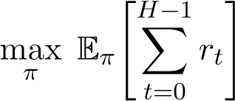
State Space Size
With five site values, three patient states, and H + 1 timesteps, the state space has 5 × 3 × (H + 1) states. For H = 10, this yields 165 states and 660 state-action pairs, making the problem fully tractable with tabular methods.

Algorithms, training, and statistical analysis
the learning rate is α = 0.1 and the discount factor is γ = 1.0. Monte Carlo Control is on-policy and first-visit. Q-Learning uses off-policy TD(0), Expected SARSA uses the expected on-policy bootstrap target, and Double Q-Learning maintains two value tables to reduce maximization bias. Value Iteration computes the optimal finite-horizon policy by backward induction using the known transition and observation models and is evaluated over 200 stochastic rollouts.
The experimental design is full-factorial: three response-separation settings, two episode horizons (H ∈ {5, 10}), three switching costs (c_switch ∈ {0, 0.1, 0.25}), and five algorithms, for 90 total configurations. Each model-free configuration is trained for 5,000 episodes across 10 independent random seeds. The primary performance metric is mean final return, defined as the average episodic return over the last 10% of training episodes for each seed.
Pairwise algorithm comparisons use Welch’s t-tests on seed-level mean final returns. Levene’s test is used for H3. Switching-cost analyses report Spearman correlations as monotonic association statistics across the three cost levels using seed-level measurements. The primary results section emphasizes the representative H = 10, c_switch = 0 case and the high-separation switching-cost sweep.

Experimental Design
Experiments follow a full-factorial design: 3 response-separation settings (high, moderate, low) ×
2 episode horizons (H ∈ {5,10}) × 3 switching costs (c_{switch} ∈ {0,0.1,0.25}) × 5 algorithms = 90 configurations. Each model-free configuration is run across 10 independent random seeds with 5,000 training episodes per seed. Value Iteration computes the exact optimal policy and evaluates it over 200 stochastic rollout episodes per seed.
The primary analysis focuses on the representative long-horizon, no-switching-cost setting
(H = 10, c_{switch} = 0). Switching-cost effects are analyzed across all three cost levels in the high-separation setting.

Results

Reward separability improves learning performance (H1)
Figure 1 shows learning curves for H = 10 and c_switch = 0. In the high-separation setting, the temporal-difference methods stabilize near mean returns of 4.6–4.7, whereas Monte Carlo stabilizes lower near 4.1. In moderate separation the same ordering persists but shifts downward to roughly 3.1–3.3 for the temporal-difference methods. In low separation, all model-free methods flatten near 1.8–2.0. The same qualitative ranking holds for H = 5 in the original appendix, with lower achievable returns because the horizon is shorter.
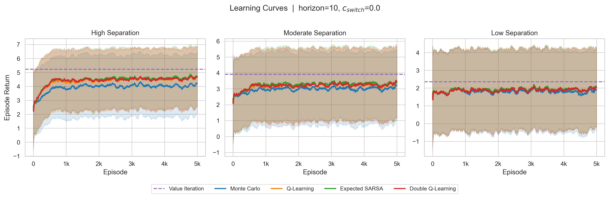
Figure 1: . Learning curves for H = 10 and c_switch = 0. Value Iteration provides the upper bound, and the temporal-difference methods stabilize above Monte Carlo across response-separation settings.
Table. 3. Mean final return ± standard deviation for H = 10 and c_switch = 0 (n = 10 seeds).
Algorithm | High separation | Moderate separation | Low separation
Value Iteration | 5.235 ± 0.436 | 3.880 ± 0.589 | 2.340 ± 0.530
Expected SARSA | 4.674 ± 0.107 | 3.323 ± 0.090 | 1.965 ± 0.139
Double Q-Learning | 4.593 ± 0.147 | 3.317 ± 0.141 | 1.942 ± 0.137
Q-Learning | 4.589 ± 0.144 | 3.260 ± 0.144 | 1.951 ± 0.113
Monte Carlo | 4.081 ± 0.232 | 3.059 ± 0.140 | 1.801 ± 0.128

Welch’s t-tests strongly support H1: every model-free method achieves significantly higher mean final return in high separation than in low separation (all p < 0.001). Monte Carlo is significantly below all three temporal-difference methods in every separation setting (all p < 0.05). No statistically significant pairwise differences are detected among Q-Learning, Expected SARSA, and Double Q-Learning (all p > 0.17), although Expected SARSA has the highest point estimate in each setting.

Gap to optimal benchmark (H4)
Value Iteration exceeds every model-free method in mean final return. In the high-separation setting, all model-free methods are significantly below the benchmark (all p < 0.01). In moderate separation the gap remains significant for all methods (all p < 0.05). In low separation, Monte Carlo remains significantly below Value Iteration (p = 0.014), whereas the temporal-difference methods are only marginally non-significant (p = 0.054–0.066), reflecting both the smaller absolute gap and the higher variance of benchmark rollouts in this regime.
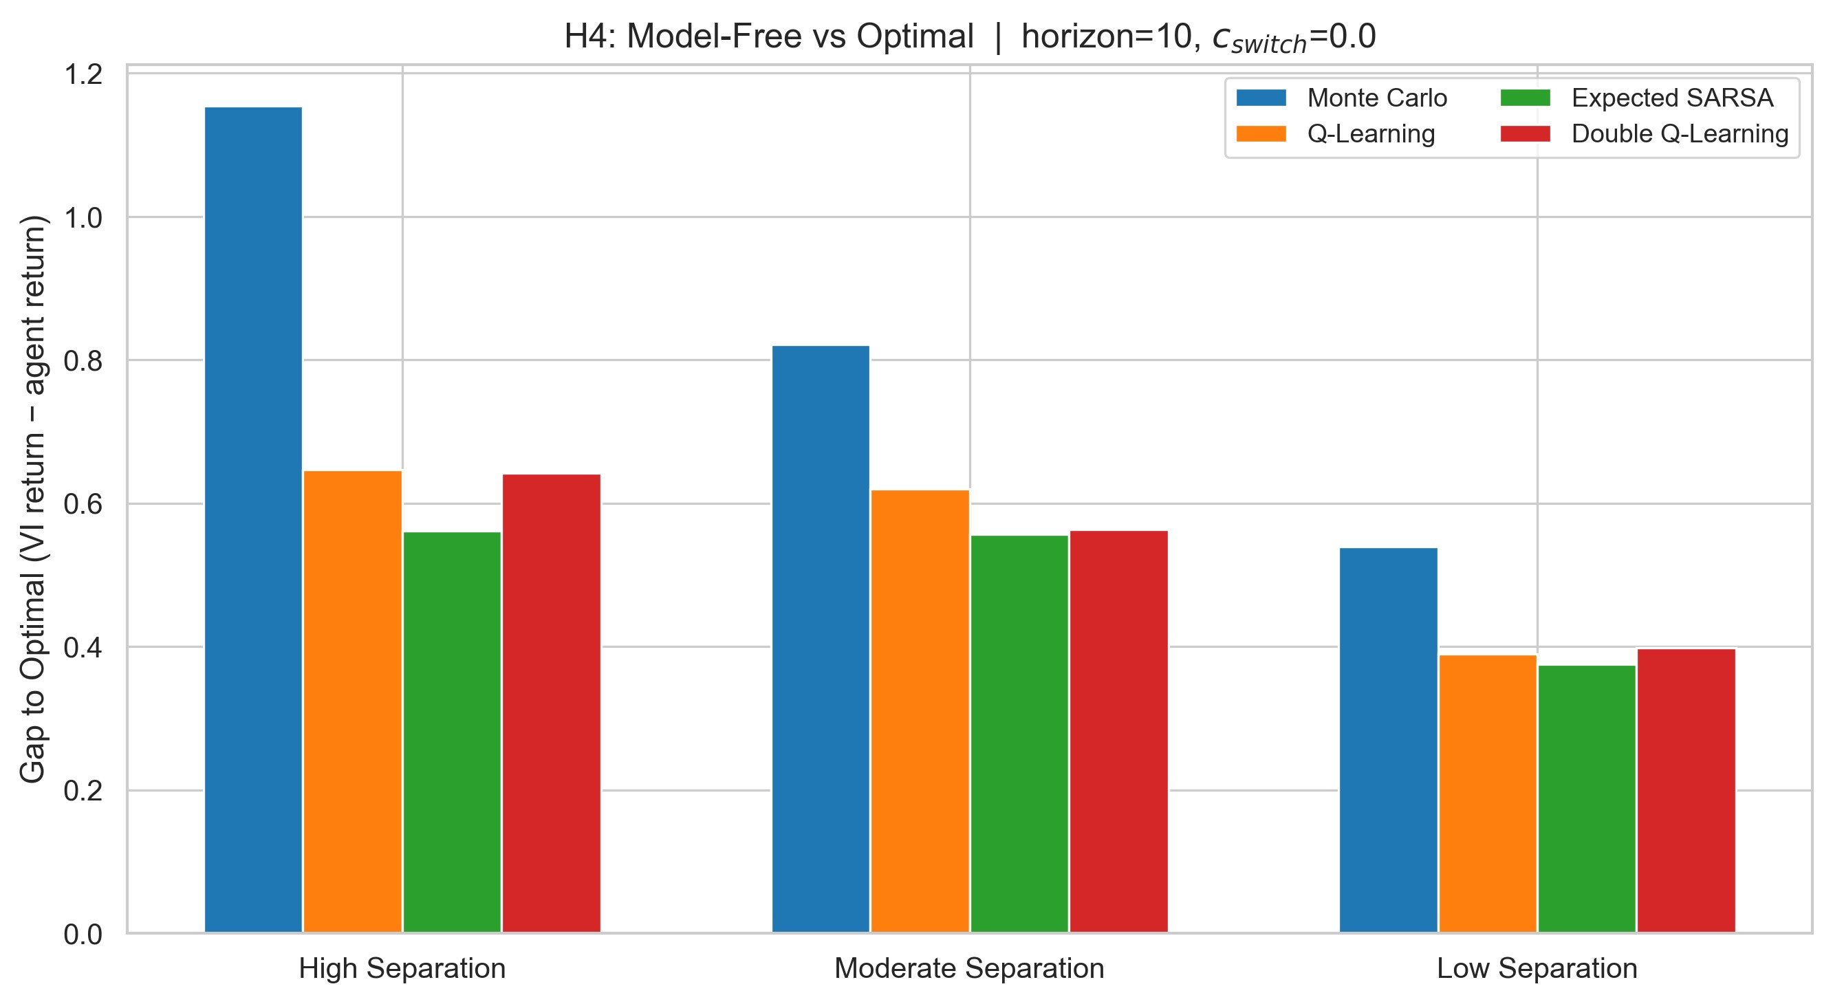
Figure. 2. Gap to optimal benchmark (Value Iteration return minus agent return) at H = 10 and c_switch = 0. Monte Carlo shows the largest gap in each response-separation setting.
Accordingly, H4 is supported in mean ordering across all settings and is statistically supported in the high and moderate separation regimes. The temporal-difference methods recover between 84% and 89% of the benchmark return, substantially narrowing the gap left by Monte Carlo.

Switching cost shapes policy behavior
Figure 3 and Table 4 summarize the switching-cost sweep in the high-separation setting. For every algorithm, switching frequency decreases monotonically as c_switch increases from 0 to 0.25, while non-receptive occupancy rises in parallel. These coupled trends expose the central control dilemma in the environment: switching less reduces immediate penalty but increases exposure to degraded response states.
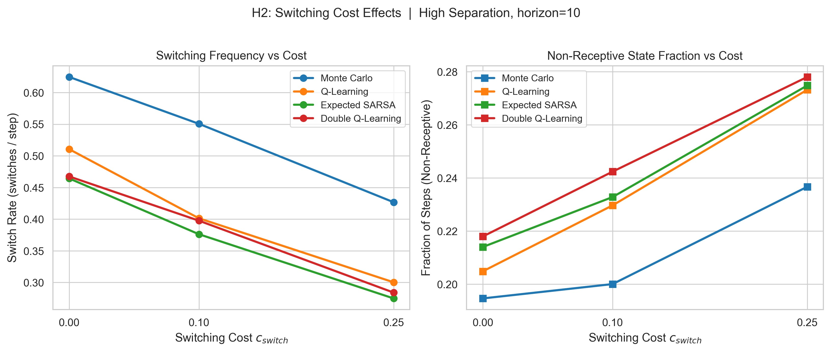
Figure. 3. Switching-cost effects in the high-separation setting at H = 10. Switch rate decreases with cost, while non-receptive state occupancy increases.

Table 4: Switching rate and non-receptive fraction by switching cost in the high-separation setting at H = 10.
Algorithm | c = 0 switch rate | c = 0.1 | c = 0.25 | c = 0 non-rec | c = 0.1 | c = 0.25
Monte Carlo | 0.625 | 0.551 | 0.427 | 0.195 | 0.200 | 0.237
Q-Learning | 0.511 | 0.401 | 0.300 | 0.205 | 0.230 | 0.273
Expected SARSA | 0.464 | 0.376 | 0.275 | 0.214 | 0.233 | 0.275
Double Q-Learning | 0.467 | 0.398 | 0.284 | 0.218 | 0.242 | 0.278

Across model-free methods, switching frequency is negatively associated with c_switch (ρ = −0.83 to −0.94, all p < 0.001), whereas non-receptive occupancy is positively associated with c_switch (ρ = 0.76 to 0.85, all p < 0.001). These results support H2.

Site preference, state occupancy, and return stability
Converged policies strongly prefer S1, the site with the highest expected reward in the baseline and receptive states. Value Iteration allocates approximately 77% of actions to S1, the temporal-difference methods allocate 67–71%, and Monte Carlo allocates about 53%. All methods keep the process in baseline-plus-receptive states for the majority of episode time, while Value Iteration achieves the lowest non-receptive occupancy.
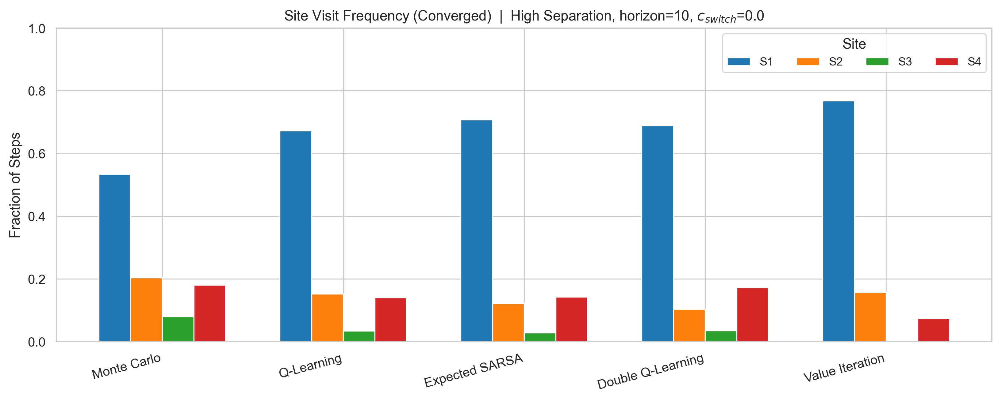
Figure 5. Converged site visit frequency in the high-separation setting, H = 10, c_{switch} = 0. All methods prefer S1. Value Iteration concentrates most aggressively; Monte Carlo distributes visits most broadly.
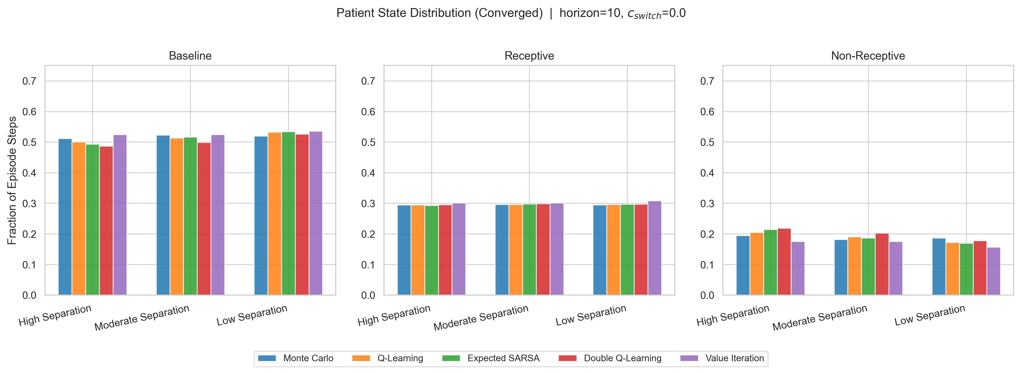
Figure. 4. Converged site-visit frequency and patient-state occupancy for H = 10 and c_switch = 0. Policies concentrate on S1 while maintaining most episode time in baseline and receptive states.
These non-uniform action distributions support H5 and show that the learned policies are structured rather than random. H3 is not supported: Levene’s test finds no significant difference between the return variances of Q-Learning and Double Q-Learning in high, moderate, or low separation (p = 0.780, 0.920, and 0.650, respectively).
Table. 5. Summary of hypothesis outcomes.
Hypothesis | Outcome | Test | Key result
H1: Higher separation → higher return | Supported | Welch’s t-test | High vs. low: all model-free methods p < 0.001
H2: Higher c_switch → less switching, more non-receptive | Supported | Spearman association | |ρ| > 0.76, p < 0.001
H3: Double Q-Learning has lower return variance | Not supported | Levene’s test | p > 0.65 in all settings
H4: Model-free < Value Iteration | Partially supported | Welch’s t-test | Significant in high and moderate settings
H5: Structured site preferences | Supported | Qualitative + descriptive | S1 concentration 53–77%

Discussion
The results support the central modeling claim of the study: once responsiveness depends on stimulation history, stimulation-site selection is a sequential control problem rather than a static bandit problem. The switching-cost analysis makes this especially clear. In a bandit setting, switching cost would simply discourage alternation. Here, staying too long at one site also changes future state occupancy, so the policy must balance immediate penalty against delayed degradation of responsiveness.
The temporal-difference methods consistently outperform Monte Carlo, which is compatible with faster credit assignment in a finite-horizon problem where present actions influence later reward through state transitions. At the same time, the absence of statistically significant pairwise differences among Q-Learning, Expected SARSA, and Double Q-Learning should not be interpreted as formal algorithmic equivalence. The correct inference is narrower: with the present sample size and this small tabular environment, no pairwise difference was detected among the three temporal-difference methods.
Several limitations qualify the interpretation. First, the transition and observation models are hand-specified and are not clinically calibrated. Second, the environment is fully observed and discrete, whereas clinically realistic control may require latent-state or partially observable models. Third, no explicit static-policy or contextual-bandit baseline was evaluated, so claims about superiority over a static controller should be deferred. Fourth, the model-free agents are evaluated at the exploration floor (ε = 0.05), whereas Value Iteration is evaluated as a deterministic optimal policy, which slightly favors the benchmark.

Conclusion
Adaptive multi-site stimulation was formulated as a finite-horizon MDP with state-dependent EEG-derived reward dynamics. Across 90 configurations, the temporal-difference methods consistently outperformed Monte Carlo, Value Iteration remained the optimal benchmark, and increasing switching cost produced a clear tradeoff between switch frequency and non-receptive occupancy.
No statistically significant variance advantage for Double Q-Learning over Q-Learning was detected in this small tabular setting. Overall, the results support reinforcement learning as an appropriate framework for history-dependent stimulation control and motivate future extensions to partially observable and clinically calibrated environments.

References
- Hasselt, H. van. (2010). Double Q-Learning. Advances in Neural Information Processing Systems, 23, 2613–2621.
- Pineau, J., Guez, A., Vincent, R., Panuccio, G., & Bhomick, S. (2009). Treating epilepsy via adaptive neurostimulation: A reinforcement learning approach. International Journal of Neural Systems, 19(4), 227–240.
- Sutton, R. S., & Barto, A. G. (2018). Reinforcement Learning: An Introduction (2nd ed.). MIT Press.
- van Seijen, H., van Hasselt, H., Whiteson, S., & Wiering, M. (2009). A theoretical and empirical analysis of Expected Sarsa. IEEE Symposium on Adaptive Dynamic Programming and Reinforcement Learning, 177–184.
- Watkins, C. J. C. H., & Dayan, P. (1992). Q-Learning. Machine Learning, 8(3–4), 279–292.

A Appendix. Additional Figures
Figure A1 shows the optimal Q-value surface from Value Iteration at t = 0 in the high-separation setting. The heatmap confirms that the optimal policy is state-dependent: from baseline and receptive states, action S1 is generally preferred, but from non-receptive states the preferred action shifts as the agent seeks to switch sites and promote recovery.
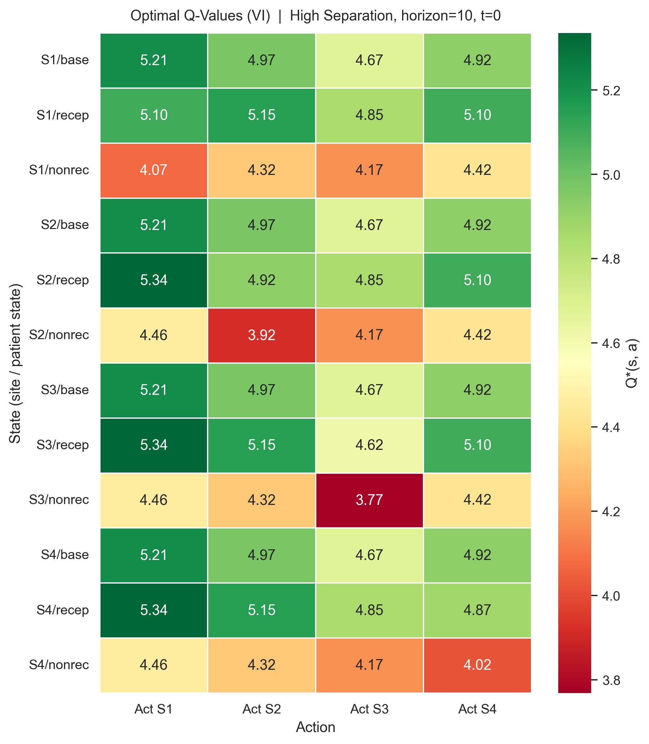
Figure A1: Optimal Q-values from Value Iteration at t = 0, high-separation setting, H = 10. Rows: (site, patient state) pairs. Columns: actions. The optimal policy shifts with patient state, confirming state-dependent sequential control.
Figure A2 shows learning curves for the short-horizon setting (H = 5, c_{switch} = 0). The same qualitative ranking holds: TD methods outperform Monte Carlo, and Value Iteration provides the upper bound. The achievable return scale is lower because episodes are shorter.
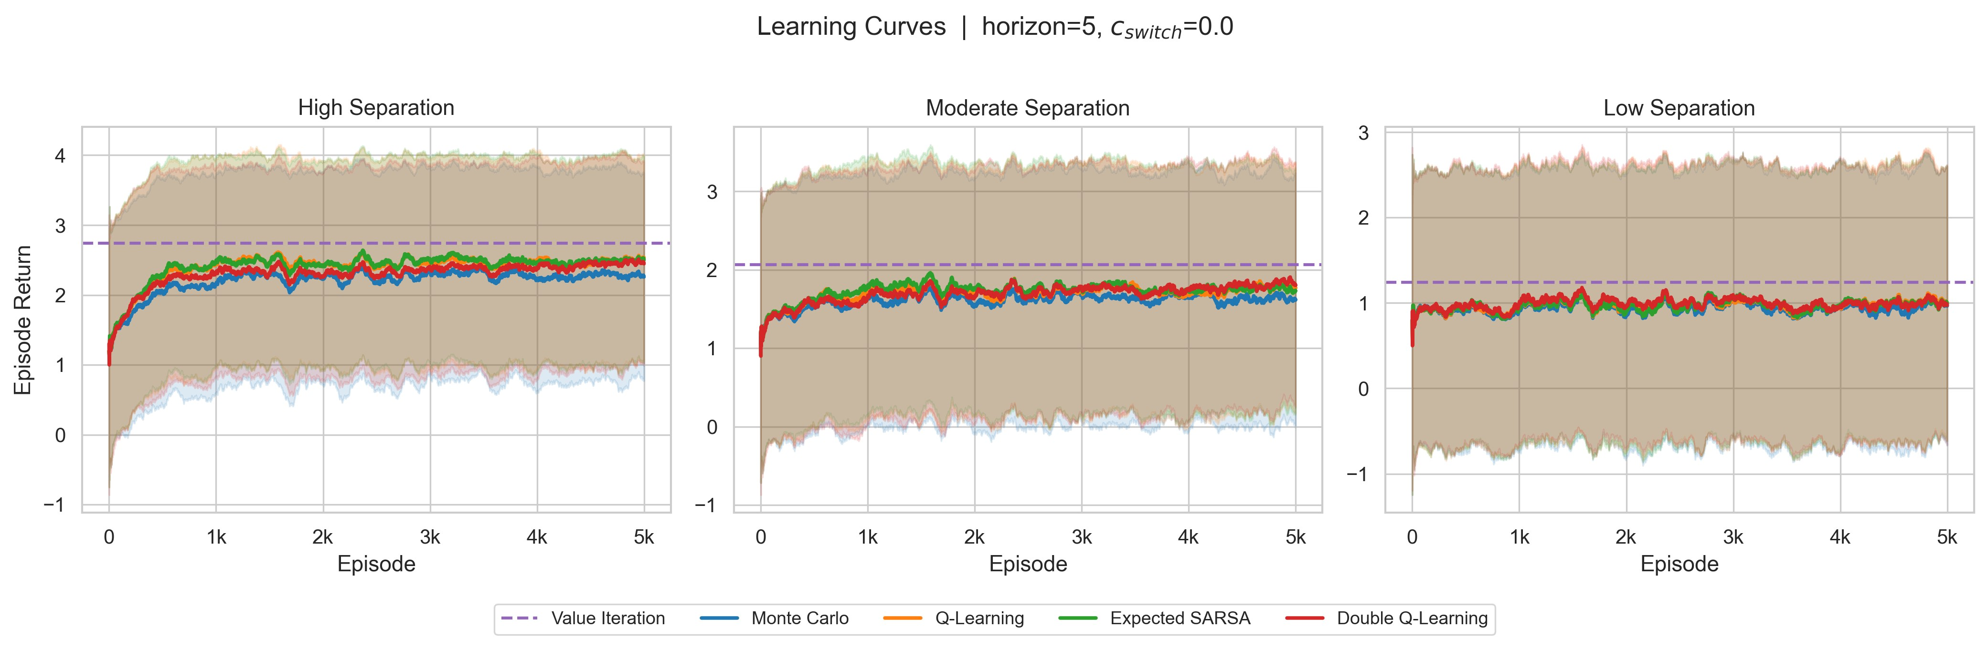
Figure A2: Learning curves for H = 5, c_{switch} = 0. The same algorithm ranking holds as in the H = 10 setting, but total return is lower due to the shorter episode.

